**IN 1900**

**Faculty of Information Technology**

**Punch Card Based Prescription System**

**Group Number -37**

|  |  |
| --- | --- |
| Index number | Name |
| 184116R | W.P.C.P.Pathirana(Group leader) |
| 184038E | E.A.Y.R.Edirisinghe. |
| 184065H | G.B.S.Jayawardana. |
| 184059T | M.D.D.S.Jayanath. |
| 184140J | D.H.D.N.Rathnayake. |

Supervisor’s Name : Mr. B. H. Sudantha Signature of Supervisor :

: Mr . D.K. Withange

Date of Submission :20/01/20

**Table of content**

Table 1.0

|  |  |  |
| --- | --- | --- |
|  | Topic | Page number |
| 1 | Introduction | 1 |
| 2 | Literature Survey | 2 |
| 3 | Problem in brief & Proposed Solution   * Problem in brief * Proposed Solution | 3 |
| 4 | System Description | 4-6 |
| 5 | Testing and Implementation | 7-10 |
| 6 | Action plan for the remaining work | 11 |
| 7 | Estimated cost and Expenditure so far | 12 |
| 8 | Individual Contribution to the project | 13-16 |
| 9 | Appendix -D   * References | 17 |

**1.0 Introduction**

When we consider the entire health sector, there are 3 main parties which are doctors, patients and the person who issues medicine (pharmacists /dispensers).The doctor-patient relationship is a central part of health care and the practice of medicine. In this case enhancing the accuracy of diagnosis and increasing the patient’s knowledge about the disease is vital. In this case the handwritten prescription method has come across as the main communication course.

Nowadays prevention of errors has been recognized as a priority in health care system. Prevention of errors at the prescribing stage is one of the most important steps in reducing these kinds of things. Due to the unreadable font/ handwriting, prescriptions can be contained unclear information as well as incomplete details. So, these are the most frequently cited proximal causes. In this handwritten prescription-based system, it will directly affect to the patients as well as to the dispensers. In here all the content in the prescription will be depended on the handwriting of the doctor. So, there is a possibility of giving wrong medicine to the patient by pharmacists/dispensers, Due to above problems it can be potentially harmful to the patients, such as hazardous drug-drug interactions, inappropriate doses or directions, adverse drug reactions, allergy to drugs and drug duplications.

So far we have been able to identify several problems and found feasible solutions and addressed them successfully. However, we had several setbacks. And we have identified proper techniques to overcome them.

Figure  **Unreadable handwriting in prescriptions**

Figure 2

**2.0 Literature Survey**

The best solution is to build a CNC (Computer Numerical Control) machine to print a PUNCH CARD which will be given to the particular patient instead of giving a handwritten prescription.

So to perform that task, we looked at various CNC machines and designed a new machine to do this task effectively and effeciently. It was one of our project objectives to produce the wanted outcomes.

We have already referred the structure of **CNC** MILLINGmachine to get an idea to create the punch card printer.

**CNC MILLING** machine

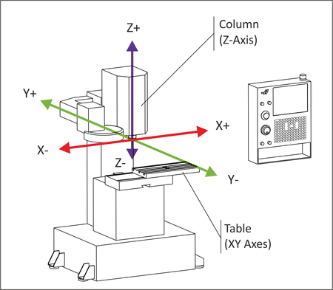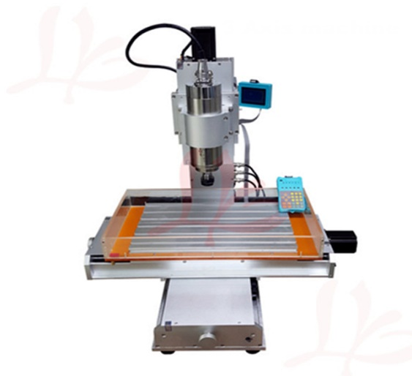

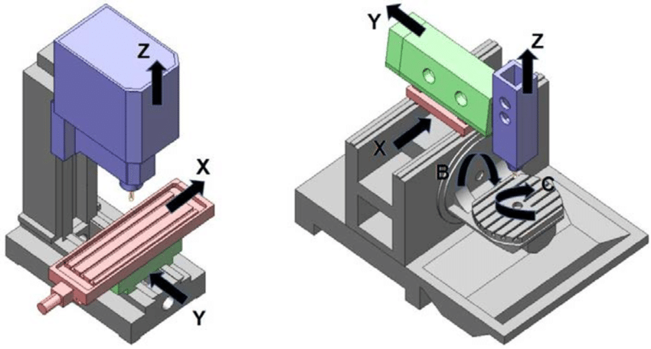

(Figure 2.3) 3D view of axis

Figure .2 Functional view of Axis

Figure 2.1:CNC MILLING machine

**3.0 Aim and objectives**

**Aim**

1. Inventing a new method of prescription and developing efficient system for both pharmacies and hospitals.

**Objectives**

* To create a CNC machine (punch card printer) to print the relevant punch card
* To design the punch card
* To find the suitable way to transfer data to the device from computer
* To design the most suitable system to read the punch card (punch card reader)

**4.0 System Description**

When considering about our main problem (prescription issue), we are planning to implement a punch card technology instead of a handwritten prescription. Every medicine has a specific binary code(4 bits – That means we are using only 24(16) different types of medicine) which is stored in a database . Initially we can divide our structure into two major parts.

* + 1. **A printer to print the punch card**
    2. **A punch card reader.**

So we can introduce punch card printer to the doctor and he doesn’t want to write the prescription manually and punch card reader can be introduced to the pharmacist which can be decoded the punch card into the medicine. Because of that pharmacists / dispensers also don’t want to read the prescription by hard. So, the core parts of the system shown below.

* **Doctor will enter the details to the system and punch card will be printed automatically (Punch card consists of rows and columns which have holes according to the given code of the medicine.)**
* **Punch card reader consists of LDR (photoresistors) and LEDs/lasers to detect the holes in the punch card. (Punch card will be passed through the reader)**
* **A display will be placed to show the prescription and now dispensers can read it and give the correct medicine without any extra effort.**

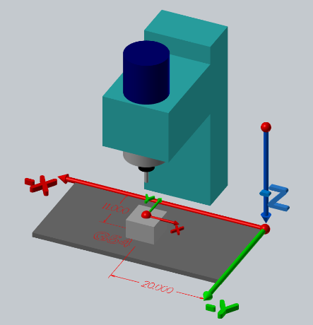

Figure Puncher

**Stepper motor 1**

**Flow Diagram of the PUNCH CARD Printer**

**Block diagram of the PUNCH CARD READER**

Stepper motor 3

Stepper motor 2

X axis

Puncher

Database

Atmega32

Microcontrollor

Stepper motor 1

Y axis

Interface

USB module

Output

Input

process

(Analog signal patterns for each medicine) Punch card

(

Going through LEDs and LDR combination

Atmega32 ADC

LCD Display

(Decoed medicine)

Analog to digital conversion

Figure

**5.0 Testing and Implementation**

First our objective is to make the Punch Card printing machine (CNC machine). This machine consists of

1. Punching mechanism
2. X axis (which can access the rows of the punch card
3. Y axis (which can access the columns of the punch card
4. Stepper motors to control the both X, Y Axis as well as the puncher

**Things we considered when preparing the punch card printer**

1. Programming ATMEGA32 with blinking LEDs with patterns and Controlling stepper motors
2. Studying different types of stepper motors (Unipolar, Bipolar) and controlling them using H bridges and motor driver boards
3. Studying about CNC machines
4. Designing the Punch Card ( the final Output)
5. Learning about Database and developing a database to implement
6. Designing the Interface to input the current medicine
7. Designing the Punch card Printer
   1. Designing the puncher
   2. Fixing the Y axis with stepper motors and testing

**3D view of the Punch Card Printer**

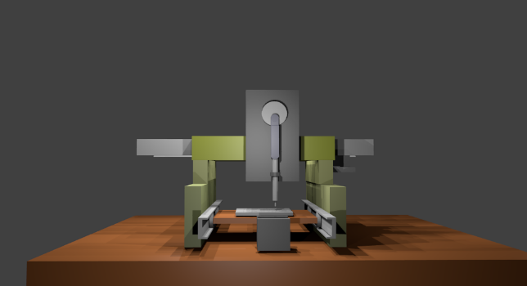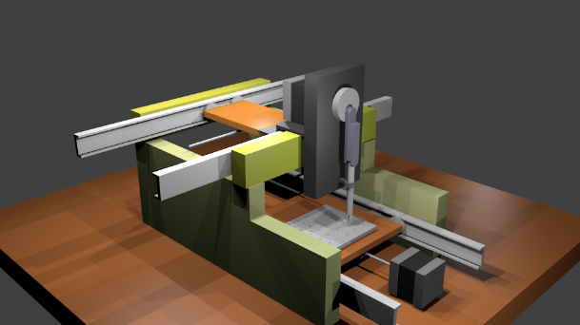

Figure 7

Figure

**Structure of the Punch Card**

Figure

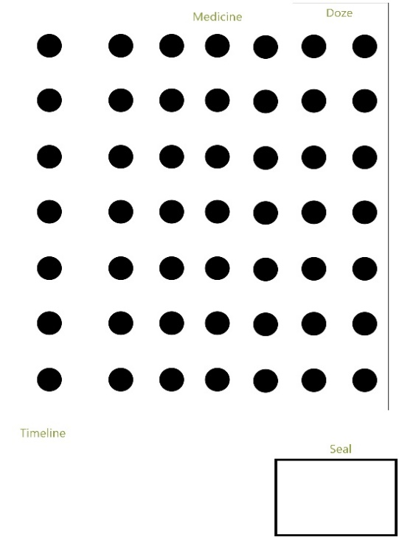

Medicine

Quantity

Seal

Timeline

As we are making a prototype of a Punch Card Machine, we are implementing this mechanism only for a limited number of medicine (16 types 4 bits code per each medicine).As the same there are 3 columns reserved for the quantity(eg - 50mg, 100mg, 500mg etc…) of the medicine . Then According to the given time interval (timeline) Puncher will give punch at a location. After all the codes has been printed, puncher should come to the starting point.

**Current progress of the Punch card printer**

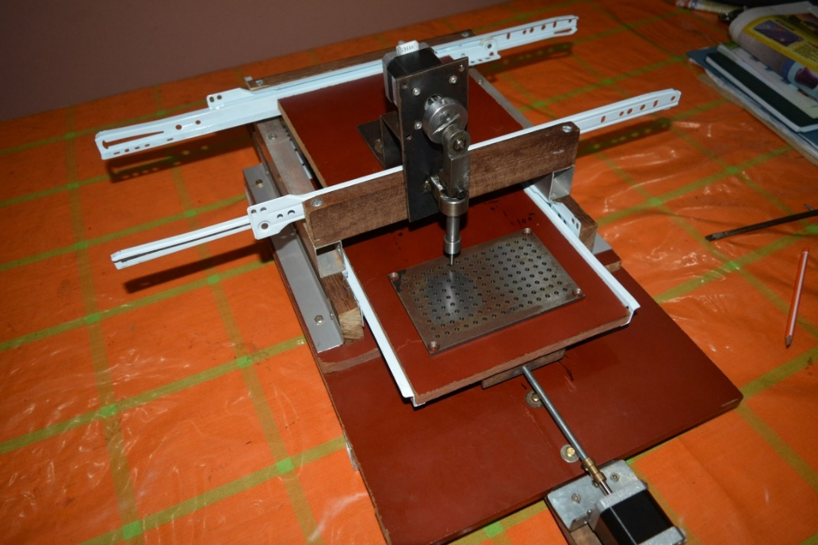

Y Axis

Puncher

Railings

Metal plate

Thread Bar

Figure Puncher

Figure (Metal Plate)

**Punch Card Reader**

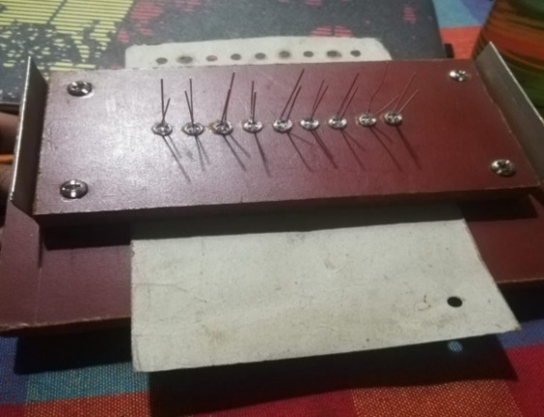

Figure (Top View of the Punch Card Reader )

Work in Progress

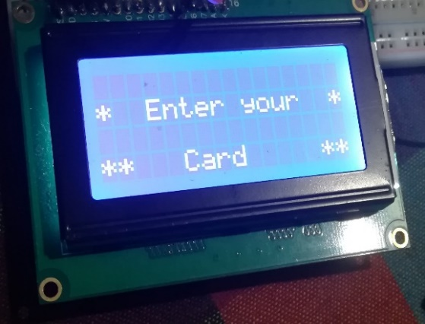

Figure (16*4 LCD Display to display the current MEDICINE)

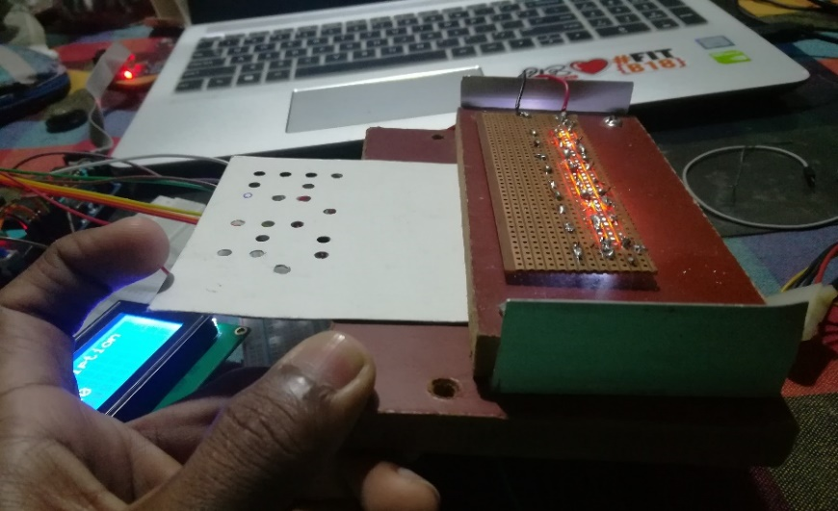

Figure

(Passing the punch card in between LED array and LDR array)

Work in progress

Figure 12 Display

Figure 13 (Prescription in the display)

Medicine name, Quantity, dose will be shown in the 16*4 display

Figure 14 (punch Card)

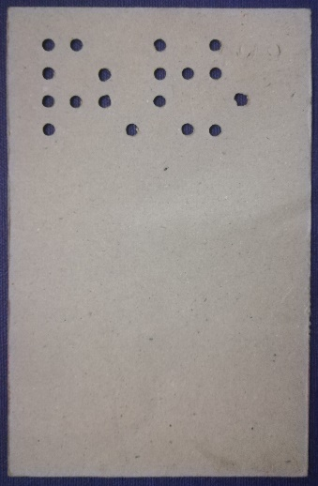

Figure 13

Sample Punch Card

(which represents specific medicine and their quantity

**Implementation**

**Testing and implementation (Punch Card Reader)**

This device consists of punch card reader with a LCD display to show the decoded details. In here we have to convert the analog signal to a digital by using the ADC in atmega32. First we have to configure the ADC by setting up ADMUX and ADCSRC registers in atmega32.

PORTA will give the digital outputs the analog signal from LDR and according to the given source code it will show the decoded details of the prescription in the LCD display.

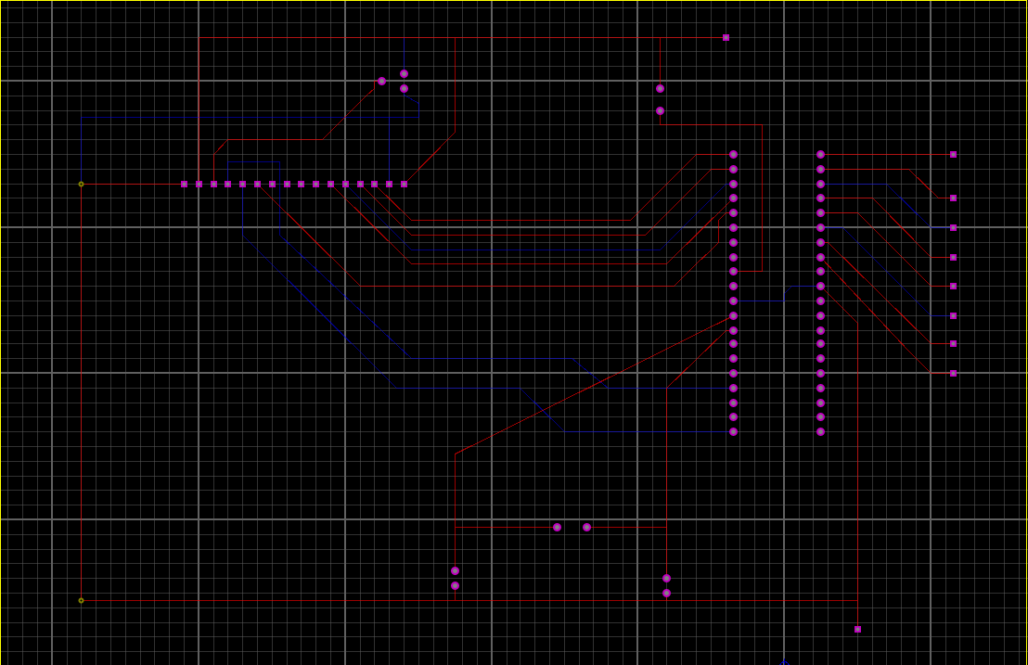

Figure 15 (PCB layout)

Figure 16 (Circuit diagram)

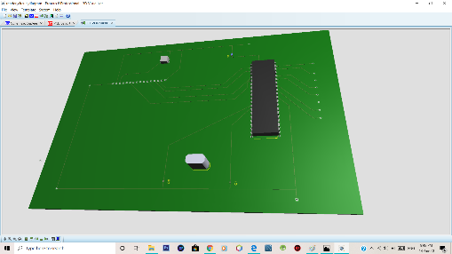

**7.0 Estimated cost and Expenditure so far**

**Hardware**

* Power supply(12V)
* Atmega32 + development board 650
* Stepper motors
  + - 1300*2 +800 3400
* Motor driver boards (420*2) 840
* Drawer railings (250*2) 500
* Linear Guide 1500
* Ball Screw 3200
* Aluminum Box bar 400
* Voltage regulators*3 + other electronics 700
* Repairing cost 550
* Power jack 60
* Nuts and bolts 200
* Guiding plates for puncher
* Capacitors, Ocillators
* Wood sheets
* Iron plates
* Display 16*4
* LED, resistors(100k,10k,100)
* LDR sensors
  + Total Rs 1**7300**

**Software**

* Atmel studio

**Appendix**

**8.0 Individual Contribution to the project**

**Name of the student:** W.P.C.P.Pathirana **(184116R)**

* Studied about various CNC machines , 3D printer and designed the most suitable structure for the Punch Card printer.
* Design the structure of the PUNCH CARD READER
* Study about the ADC conversion
* Making PCB and circuit diagrams
* Making the algorithm to implement

**Name of the student** E.A.Y.R.Edirisinghe **(184038E)**

* Designed the Interface to input the data
* Studied database management and created a database to store the data (Medicine, dose)
* Made 3D structure of the project
* Contributed to the hardware part
* Implement the connection between PC to device using UART (Serial)

Figure database

Figure Interface

**Name of the student** G.B.S.Jayawardhana **(184065H)**

* Contributed to the hardware part
* Studied stepper motor control board , voltage regulators etc.
* Contributed to Program the Microcontroller and test

**Name of the student** M.D.D.S.Jayanath **(184059T)**

* Collected data for the database
* Designed a structure for the punch card
* Make the algorithm in the punch card reader
* Contributed to the programming and testing

**Name of the student** D.H.D.N.Rathnayake **(184140J)**

* Studied about stepper motor controlling and testing
* Contributed to the coding used in punch card printer
* Design the punch card

Figure

Figure

Figure (bottom copper)

Figure (top copper)

**9.0 Appendix**

**References**

1. <https://youtu.be/57jBdK3Y>
2. <https://youtu.be/PBhftKTmdHI>
3. <https://youtu.be/Gb4VWJEYc.U>
4. <https://youtu.be/7eAnjNob8MI>
5. <https://www.google.com/url>?
6. <https://electrosome.com/interfacing-stepper-motor-8051-keil-c-at89c51/>
7. <https://en.wikipedia.org/wiki/Stepper_motor>